EXPERIMENT 11

PROCEDURES

Aim:

* Create a table with attributes students and marks.
* Insert values into the table.
* Create a procedure to get the merit students (marks > 50).
* Create a procedure to get marks of a given id (using in).
* Create a procedure to display highest marks (using out).
* Create a procedure to get marks of a given id (using in and out).
* Create a table with attributes students and marks.
* Insert values into the table.

C:\Users\sukha\OneDrive\Desktop\Telegram Desktop\Activity1\p_1.jpg

C:\Users\sukha\OneDrive\Desktop\Telegram Desktop\Activity1\p_2.jpg

* Create a procedure to get the merit students (marks > 50).

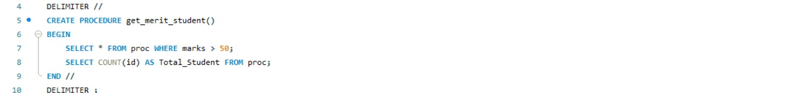

C:\Users\sukha\OneDrive\Desktop\Telegram Desktop\Activity1\p_4.jpg

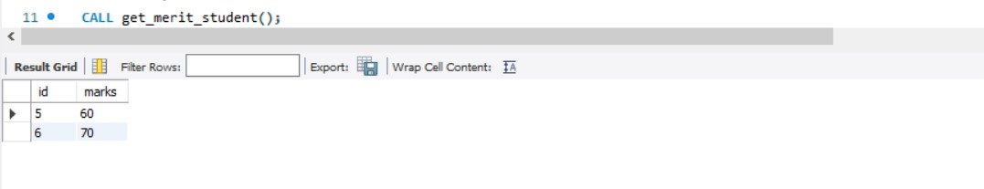

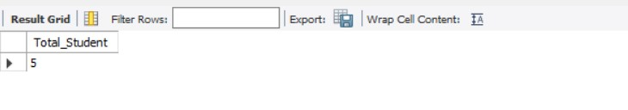 C:\Users\sukha\OneDrive\Desktop\Telegram Desktop\Activity1\p_7.jpg

* Create a procedure to get marks of a given id (using in).

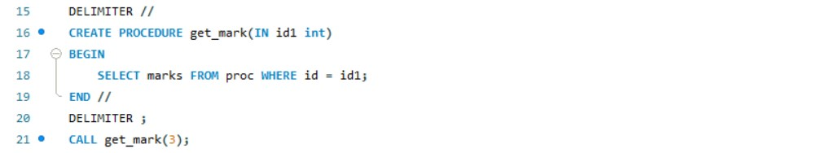

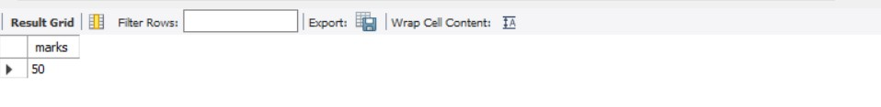



* Create a procedure to display highest marks (using out).

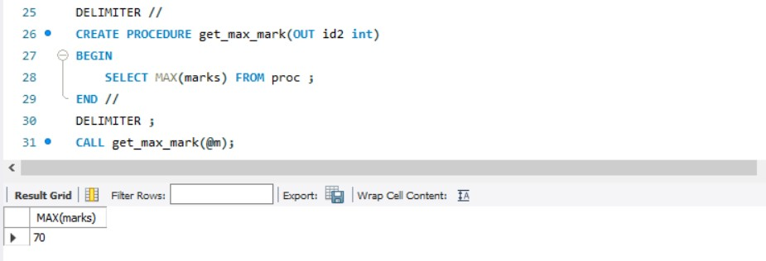

C:\Users\sukha\OneDrive\Desktop\Telegram Desktop\Activity1\p_12.jpg

* Create a procedure to get marks of a given id (using in and out).

